I2C GPS+LLC DROTEK SETTINGS

25/08/2012

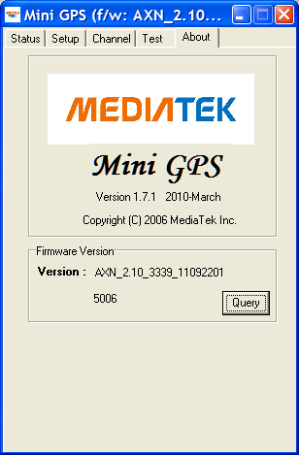

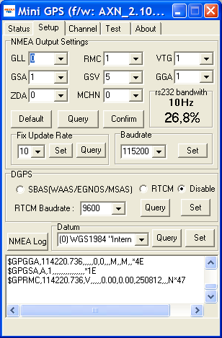

CORRECTIONS :

GSV set to 1
SBAS enabled

Software : TinyGPS 1.7 with X serial cable

